**NAME : PATRICK GICHINGA KIMANI**

**REG. NO. : C025-01-0966/2015**

**COURSE : BSc. INFORMATION TECHNOLOGY**

**UNIT CODE : BIT 2305**

**UNIT NAME : HUMAN COMPUTER INTERFACE**

**TASK : ASSIGNMENT 2**

**DATE OF SUBMISSION: JULY 25TH, 2018**

**From any computer or mobile screen pick one GUI which you do not like & one more GUI which you like.**

I like the windows 7 graphical user interface and I don’t like the ubuntu graphical user interface

**Analyze their constituting graphic / visual elements by applying principles of aesthetics and find out if you can attribute any aesthetic reasons for your ‘like’ & ‘dislike’. Keep functional & usability aspects out of the judgment for the time being.**

1. Windows 7 is not cluttered with excessive use of icons and buttons making it easy to learn.
2. Windows 7 has an attractive color thus making it more attractive for use.
3. Recognition rather than recall: The use of color schemes and icons act to denote functionalities. Example ‘Head Phone icon”. This design feature promotes recognition of rather than recall of system functionalities.
4. Windows 7 icons are graphically simple, they are not complicated to understand.
5. In terms of construction, the icons do not take expensive screen real estate; need very less computing memory; are amiable to both pixel as well as vector graphics.
6. The icon has achieved this by employing aesthetic principles in their form, color, shape, configuration. All of them are put together holistically resulting in a simple ‘design’.
7. Window 7 uses an awesome layout making it so interesting to use. It does not over use nor just use a simple interface it’s just awesome.
8. I dislike ubuntu because it has a very bad color scheme so dull and not attractive at all.
9. Ubuntu only show minimal icons that cannot help one to know how to start using it.
10. Ubuntu displays it features in a manner that is not friendly at all.

**Sketch as many alternatives as you can visualize for the two icons that depict activity progress happening in the background.**

1. 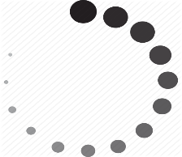 2. 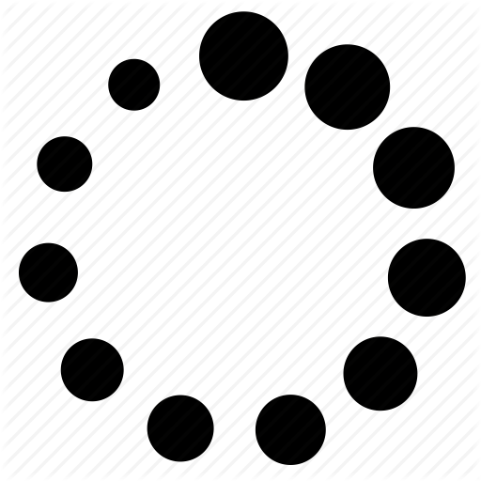 3. 

4.  5.  6. 

**Conduct a quick survey from amongst your friends as to which of the icon concepts, you have come up with, are ‘liked’ by them. You can ask them to rate each design for 10 points and empirically find out the one that is most likely to be accepted in terms of aesthetics & function representation.**

|  |  |
| --- | --- |
| No | Rate out of ten |
| 1 | 8 |
| 2 | 9 |
| 3 | 3 |
| 4 | 8 |
| 5 | 9 |
| 6 | 6 |
| 7 | 8 |
| 8 | 8 |
| 9 | 7 |
| 10 | 3 |

**You can also ask them to point out one visual element from your design that if changed will improve your design.**

Improve the color of the icons to make them more attractive such as number 1,2,5.

Number 6 should be improved to represent functionality in a better way.